CSS Units Explained
In CSS, you can specify sizes or lengths of elements using various units of measure. Some of these units of measure include PX, EM, REM, %, VW, and VH although there are several more available in CSS.
The most important aspect to learn about the different units is that some units, such as PX are absolute units, and some are relative units.
Absolute lengths: are fixed in relation to each other and anchored to some physical measurement. The absolute units are: px, mm, cm, in, pt, pc. They are mainly useful when the output environment is known.

- mm: millimeters, e.g. 10mm.
- cm: centimeters, e.g. 1cm (= 10mm).
- in: inches, e.g. 0.39in ( = 10mm).
- pt: point, where 1pt is generally assumed to be 1/72 inch e.g. 12pt.
- pc: pica, where 1pc is 12pt
- px: pixel, e.g. 14px.

In general, there are issues with all these measurement units. Millimeters, centimeters, and inches are inaccurate for a screen-based medium. Points and picas are unreliable since systems can use different dpi settings.
Relative lengths: Relative length units specify a length relative to another length.

- EM: Relative to the parent element
- REM: Relative to the root element (HTML tag)
- %: Relative to the parent element
- VW: Relative to the viewport’s width
- VH: Relative to the viewport’s height
Unlike PX, relative units like %, EM, and REM are better suited to responsive design and help meet accessibility standards. Relative units scale better on different devices because they can scale up and down according to another element’s size.

Meet the Units focusing on font-size.

Sizing with PX
Pixels (px) are considered absolute units, although they are relative to the DPI and resolution of the viewing device. But on the device, itself the PX unit is fixed and does not change based on any other element. Using PX can be problematic for responsive sites, but they are useful for maintaining consistent sizing for some elements. If you have elements that should not be resized, then using PX is a good choice.

Sizing with EM
The size of an EM is dynamic. When defining the font-size property, an EM is equal to the size of the font that applies to the parent of the element in question. If you haven't set the font size anywhere on the page, then it is the browser default, which is probably 16px.
So, by default 1em = 16px, and 2em = 32px. If you set a font-size of 20px on the body element, then 1em = 20px and 2em = 40px. To calculate the EM equivalent for any pixel value required, you can use this formula:

For example, suppose the font-size of the body of the page is set to 1em, with the browser standard of 1em = 16px; if the font-size you want is 12px, then you should specify 0.75em (because 12/16 = 0.75). Similarly, if you want a font size of 10px, then specify 0.625em (10/16 = 0.625); for 22px, specify 1.375em (22/16). This is tedious-but we can work around it!
It would be nice if we could think in pixels.
Humans are pretty good at thinking in tens since we’re familiar with the decimal (base-10) number system. If instead 1 EM were equal to 10px, we could easily translate any pixel amount to ems by dividing it by 10. So 12px would be 1.2em, 24px would be 2.4em, and so on.
How can we do this? Well, 10 is 62.5% of 16px, the default root font size of your browser. So, if we set the base font size of our document to be 62.5%, then 1em will equal 10px.
The problem with EM-based font sizing is that the font size compounds. A list within a list isn't 14px, it's 20px. Go another level deeper and it's 27px! These issues can be worked around by declaring any child elements to use 1em, avoiding the compounding effect.
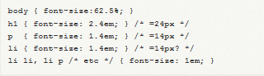
The compounding nature of em-based font-sizing can be frustrating so what else can we do?

Sizing with REM
CSS3 introduces a few new units, including the REM unit, which stands for "root em".
The EM unit is relative to the font-size of the parent, which causes the compounding issue. The REM unit is relative to the root—or the html—element. That means that we can define a single font size on the html element and define all REM units to be a percentage of that.
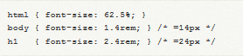
You can define a base font-size of 62.5% to have the convenience of sizing REMs in a way that is similar to using PX.
What do we do for browsers that don't support REM units? (Not an issue any more) We can specify the fall-back using PX. To do so, we specify the font-size using px units first and then define it again using rem units.
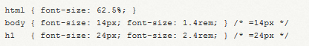
And voila, we now have consistent and predictable sizing in all browsers, and resizable text in the current versions of all major browsers.
Great video on EM v’s REM: https://www.youtube.com/watch?v=R3Ppj4DI-OI

Sizing with Percentages
Percentages are obvious in how they work. That is, they work just how you think they will. If a parent has the font-size of 20px and the child has a font-size of 50%, it will come out to 10px. Just like em's the very nature of percentage sizing is that it is relative. It also cascades in the same way, so the very problem described above of the list item applies here as well.

EM vs. Percent
In theory, both the em and the percent units are identical, but in application, they have a few minor differences that are important to consider.

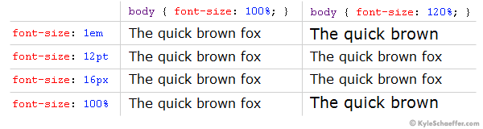
In the example above, we used the percent unit as our base font-size (on the body tag). If you change your base font-size from percent to ems (i.e. body {font-size: 1em; }), you probably won’t notice a difference. Let’s see what happens when “1em” is our body font-size, and when the client alters the “Text Size” setting of their browser (this is available in some browsers, such as Internet Explorer).

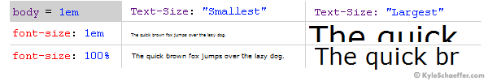
When the client’s browser text size is set to “medium,” there is no difference between ems and percent. When the setting is altered, however, the difference is quite large. On the “Smallest” setting, ems are much smaller than percent, and when on the “Largest” setting, it’s quite the opposite, with ems displaying much larger than percent. While some could argue that the em units are scaling as they are truly intended, in practical application, the EM text scales too abruptly, with the smallest text becoming hardly legible on some client machines.

What’s the right font size in web design?

Different kinds of text have different sizes.

Optimal font sizes for desktop

There are no exact rules for font sizing, but there are some generally good practices to think about when designing for desktop:

Body text - Font sizes should be around 16px to 18px for legibility (or 1.6rem to 1.8rem using our sizing rules mentioned above). Keep in mind that more expressive typefaces may be less legible, so if you can afford to go a bit larger, then, even 21px can be pleasant to read.

Headings - The headings should be around 1.96 times larger than your body text to create a sufficient contrast. This would mean that if you use 18px for body font size, then you would use around 35px for headings. Expressive or experimental type type generally works best here, since the larger size makes it more legible.

Subheadings - These should be slightly smaller than heading size, with some adjustments like less weight to create a contrast between the two. For example, if we used 35px for the heading, we should use around 30px for the subheading.

Input fields - These should closely match the body text’s rules.

Optimal font sizes for mobile
On mobile, you have less room to display your content. Additionally, users typically hold the devices closer to their eyes than they would a laptop or desktop screen - which means your typefaces can (and should) be smaller than on desktop:
- Body text - Font sizes should be at least 16px for body text. In some cases, you may be able to go smaller (for example. if a typeface has unusually large characters or you are using uppercase letters), with 14px being the smallest you should go. For context, Google’s Material Design uses a minimum suggestion of 14px for their secondary font size, while Apple’s guidelines use 15px for theirs.
- Headings - Headings should be around 1.3 times larger than your body text to create a sufficient contrast. This would mean if you use 16px for body font size, then you would use ~21px. This is scaled down from the 3.5rem we used on desktop.
- Subheadings - Here too, these would often be scaled down from the heading size, but we have a slight issue here in which the subheading may look too similar to the body font size. For this reason, some designers choose to make the subheading visually different through the use of weight, formatting like italics and letter spacing. If we used 21px for a heading, we might choose 18px or 16px for a subheading, but with lighter weight than the heading or body text.
- Input fields - These should closely match the body text’s rules.
Have a look at the following:
https://www.wix.com/studio/blog/font-size
https://www.wisegrowthmarketing.com/website-font-sizes/

These are only suggestions, they are by no means a strict rule.
The most crucial thing for sizing your text right in responsive web design is sizing your text appropriate to the reader’s distance from the device. Let’s assume that the larger the viewport is, the further it is away from the reader. A width of 370 px might be a smartphone, held closer to your body. On the other hand, a 1920 px wide viewport might be an external monitor or an iMac positioned on a desktop further away from the reader. A great tool is the Font Size Calculator by leserlich.info.
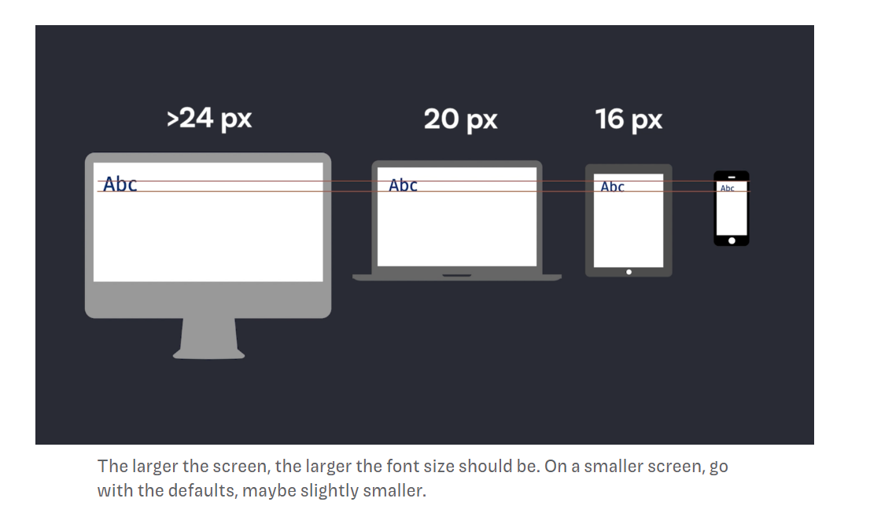
These were all rough guidelines to point you in the right direction. Bear in mind, that it will always depend on your exact application, and the typeface you choose.
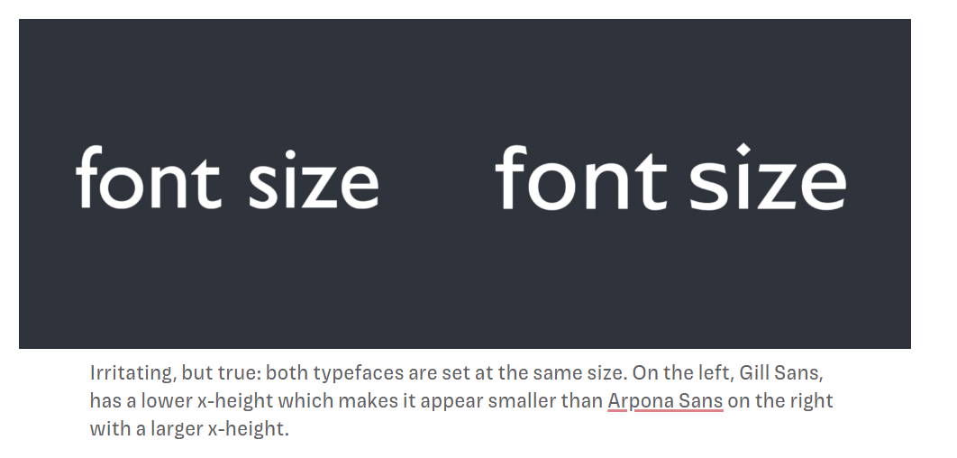
Recommendation: Using a base font size of 62.5% on the html (:root) together with REM s for font sizing, provides the ideal compromise between respecting user font size preferences and making it easier to translate pixel measurements into responsive units. Set a font-size of 1.6rem on the body so un-styled elements have a base font-size.

Sizing with vw, vh and vmin
These new CSS3 properties allow you to scale font sizes according to the viewport dimensions.
The viewport is the width and height of the viewable portion of the screen, inside the browser.
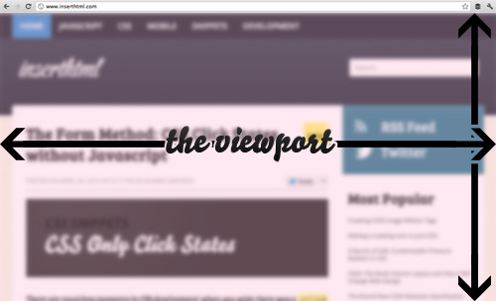
There are 3 viewport related units, which will be incredibly useful for many things. These are vh, vw and vmin.
The vw unit stands for viewport width and each unit of vw is equal to 1% of the total viewport width. For example:
div { width: 1vw; }

This would make the div 1% of the total viewport width. It would change as the screen size changed. Similarly, vh stands for viewport height, and each unit is equal to 1% of the viewport height.
The final unit, vmin calculates which is smaller, the horizontal viewport width or the vertical viewport height, and then bases its calculations off that.
For example, if the height of the viewport was smaller than the width, then 1vmin would be 1% of the viewport height.
This unit is useful for avoiding compounding in width calculations, just as rem avoids font-size multiplier compounding.
The new units will revolutionize responsive design — text on mobile devices often appears a little large because you’re holding the device closer than a monitor.

Summary
What follows is a list of suggestions, not absolute rules:
Pixels (px)
Use for: hairline borders and general elements when creating fixed-width designs; values for CSS shadow displacement. Avoid using in @media breakpoints, as doing so breaks pages when they are zoomed: use rem or em instead.
Don’t use for: typography.

Percentage (%)
Use for: making responsive images and containers; setting height on the body in some cases. HTML base font-size.

em, ex
Use for: typography, and elements related to typography (paddings, for example), with the understanding that em has subtle “gotchas” when used in complex layouts. Consider using rem as an alternative. The general advice is to avoid em if the element you're styling doesn't have an explicit font size.

Points and picas
Use for: print stylesheets.
Don’t use for: anything else.

rem
Used as: a more robust and predictable alternative to em and ex, and employed for the same purposes, including @media query breakpoints.

Viewport units (vh & vw)
Use for: responsive typography; “perfect” responsive containers.

Inches (in) and Centimeters (cm)
Use with: print stylesheets, especially page margins
Don’t use for: anything else.

Absolute Font Sizing Keywords
Several absolute font-sizing keywords are available. The font size is determined from a browser preset and the element will not inherit its parent’s size. Each
<absolute-size> keyword value is sized relative to the medium size and the individual device's characteristics, such as device resolution.

- xx-small An absolute size 60% the size of medium.
- x-small An absolute size 75% the size of medium.
- small An absolute size 89% the size of medium.
- medium A user's preferred font size. This value is used as the reference middle value.
- large An absolute size 20% larger than medium
- x-large An absolute size 50% larger than medium.
- xx-large An absolute size twice the size of medium.
- xxx-large An absolute size three times the size of medium.

- font-size: xx-small;
- font-size: x-small;
- font-size: small;
- font-size: medium;
- font-size: large;
- font-size: x-large;
- font-size: xx-large;

Relative Font Sizing Keywords
Two relative font-sizing keywords are available. The font is sized according to its parent element:

- font-size: smaller;
- font-size: larger;

For example, if the parent has a font size of ‘medium’, a value of ‘larger’ will set the element to ‘large’.

CSS Typography Conversion Reference
It’s an approximation, which will depend on font, browser, and OS, but it’s a good starting point.
Conversion Table
Points  (for print css) | Pixels | Ems | Percent | HTML Size | Keyword
6 pt | 8 px | 0.5 em | 50%
7 pt | 9 px | 0.55 em | 55% |  | xx-smal
7.5 pt | 10 px | 0.625 em | 62.5% | 1 | x-small
8 pt | 11 px | 0.7 em | 70% | H6
9 pt | 12 px | 0.75 em | 75% | 2
10 pt | 13 px | 0.8 em | 80% | H5 | small
10.5 pt | 14 px | 0.875em | 87.5%
11 pt | 15 px | 0.95 em | 95%
12 pt | 16 px | 1 em | 100% | 3  H4 | medium
13 pt | 17 px | 1.05 em | 105%
13.5 pt | 18 px | 1.125 em | 112.5% | 4
14 pt | 19 px | 1.2 em | 120% | H3 | large
14.5 pt | 20 px | 1.25 em | 125%
15 pt | 21 px | 1.3 em | 130%
16 pt | 22 px | 1.4 em | 140%
17 pt | 23 px | 1.45 em | 145%
18 pt | 24 px | 1.5 em | 150% | H2 | x-large
20 pt | 26 px | 1.6 em | 160% | 6
22 pt | 29 px | 1.8 em | 180%
24 pt | 32 px | 2 em | 200% | H1  6
26 pt | 35 px | 2.2 em | 220%
27 pt | 36 px | 2.25 em | 225%
28 pt | 37 px | 2.3 em | 230%
29 pt | 38 px | 2.35 em | 235%
30 pt | 40 px | 2.45 em | 245%
32 pt | 42 px | 2.55 em | 255% |  | xx-large

http://pxtoem.com/ PX to EM conversion made simple.

Measurement Units for everything else
EM
Relative unit that responds to text-size preferences.
Using margins as an example, the EM unit scales the margins according to the size of the font of the container/ element or if the container does not have a font-size associated with it uses the nearest font-size.
Let's take this example:
h1 {margin-top:2em}
This sets the top margin for h1 heading to 2 times the height of the h1 font-size.
div.box {margin: 2em; width: 20em;}
Create a box about 20 times the default font size, with a 2x the default font size margin around it. The default font-size is either set in the body or the browser. The body is checked first.
.Heading
{
font-size: 20px;
margin-bottom : .05em;
}
A class named Heading, which sets the font size to 20 Pixels, and the margin-bottom property (which defines the style of the bottom margin of the element that will use this class) to .05em. The nearest font size property is in the same rule, and has a value of 20px, so .05 means one pixel only.
Percentages
Relative to the size of the container.
Percent works similarly to em, except that it's more selector-specific.
In the text-indent, margin, padding, and width properties, percentage values are relative to the width of the parent element. You'll remember that an element is contained within another element (for example, a <paragraph> will be inside the <body>). Usually, percentage values specify a percentage of the parent.
For example, specifying a width property with a percentage value means the width of an element will be the given percentage of the element which contains it. For instance, p {width: 75%} means that paragraphs will be 75% the width of their container. Often this will mean the body element.

Review:
https://blog.hubspot.com/website/css-font-size#:~:text=Absolute%2Dsize%20keyword&text=Note%20that%20in%20HTML%20the,x%2Dsmall
https://blog.logrocket.com/the-elements-of-responsive-typography/
https://www.freecodecamp.org/news/how-to-start-thinking-responsively/
https://bits.theorem.co/css-pro-tips-responsive-font-sizes-and-when-to-use-which-units/
https://www.smashingmagazine.com/2016/05/fluid-typography/

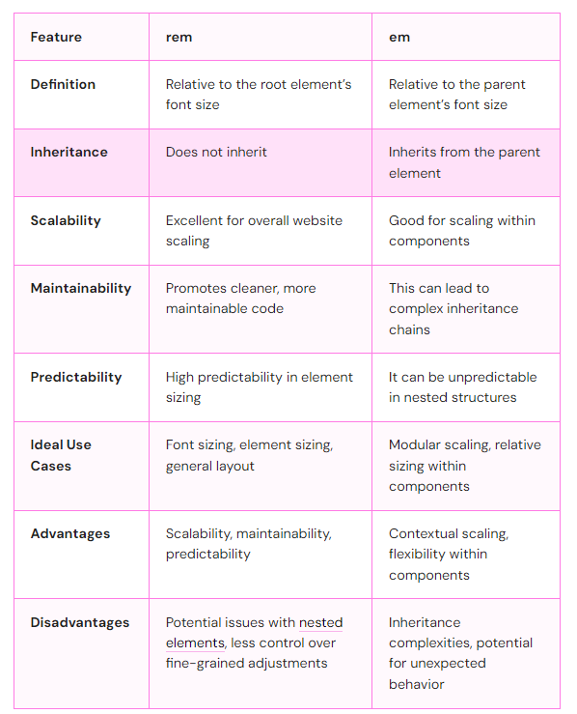

Picking the Right CSS Unit: What to Think About

When you’re building a website, choosing the right CSS unit is important. Here’s what you should consider:

How Big is Your Project?
The size of your project matters:
- Big websites: ‘rem’ might work better. It’s easier to scale and keep tidy.
- Small projects or reusable parts: ’em’ could be a good fit. It’s more flexible.

What’s Your Design Goal?
Think about what you want to achieve:
- The whole website looks good together: ‘rem‘ is better.
- Parts that can fit anywhere: ’em’ could be the way to go.

Is Your Site Easy for Everyone to Use?
Making your site work for all users is key:
- ‘rem’ is linked to the main font size. This can make it easier for users to change text size without messing up the layout.
- ’em’ can work, too, but you need to be careful about how sizes change within parts of your site.

Does Your Site Work on All Devices?
Both ‘rem’ and ’em’ can work well for sites that look good on all screens. But:
- ‘rem’ is more predictable. It always relates to the main font size.
- ’em’ can sometimes surprise you, especially in complex layouts. You’ll need to test it more.

Using ‘rem’ and ’em’ Together: Best Ideas

You don’t have to pick just one. Using both ‘rem’ and ’em’ can make your site even better. Here’s how:
- Start with ‘rem’ for the basics: Set your main font size with ‘rem’. This sets the stage for your whole site.
- Use ’em’ for parts that need to fit anywhere: For things like buttons or menus, ’em’ helps them fit in wherever you put them. Use “em” for components that need to scale with their parent. The relative sizing to the parent element offers a unique advantage, especially in scenarios that require components to scale in harmony within their immediate context.
- Stick to ‘rem’ for the big stuff: Use ‘rem’ for the main layout, like how wide things are or how much space is between sections. It keeps things consistent.
- Use “rem” for global elements like body text and headings. As an rem value is derived from the root element, it'll be consistent throughout the entire webpage.

- Mix it up for nested parts: If you have things inside other things, try using both. Use ’em’ for sizes within a component and ‘rem’ for anything that needs to match the overall layout.

